Cross-quantilogram: USDCHF and EURGBP
Method 20 / daily log returns / expanding quantiles / Alpari D1 full available history

Study setup
Logical pair: USDCHF , EURGBP
Broker symbols: USDCHF_i , EURGBP_i
Snapshot: 2026-11-03_majors_alpari_D1
Timeframe: D1
Matched return window: 1999-01-06 to 2026-11-02 (UTC bar dates)
Matched return count n: 7182
Dropped unfinished last bar dated 2026-11-03 UTC after a tick-volume check against the prior complete day.
Quantiles: expanding window, min history 252 days
tau in [0.05, 0.2]; k=0..10; headline tau=0.05, k=1
Complete matched rows (Excel): USDCHF-EURGBP_CQ_D1.xlsx
Complete matched rows (HTML table): USDCHF-EURGBP_CQ_D1_data.html

Method carried forward
The cross-quantilogram rho_tau(k) measures linkage among centered quantile-hit indicators of matched daily log returns of close, ln(close_t / close_t-1). Quotes are not inverted. At each date t, the tau-quantile uses only returns through t (expanding window) after a minimum history of 252 days. Hits are h_t = 1(r_t < q_t) - tau. rho_tau(k) is the normalized cross-product of h_x,t with h_y,t+k. Levels tau in {0.05, 0.20} and lags k=0..10 are pre-specified; headline is tau=0.05, k=1 both directions. Same-sample Pearson r is a side check. This is not causation and not a trading signal.

Results (headline)
rho_USDCHF->EURGBP(tau=0.05,k=1): 0.039404
rho_EURGBP->USDCHF(tau=0.05,k=1): 0.031086
rho_USDCHF->EURGBP(tau=0.20,k=1): 0.036463
rho_EURGBP->USDCHF(tau=0.20,k=1): 0.014220
Pearson r: -0.325886

CQ table (tau=0.05)
k | rho_USDCHF_to_EURGBP | n_USDCHF_to_EURGBP | rho_EURGBP_to_USDCHF | n_EURGBP_to_USDCHF
0 | -0.01049021 | 6931 | -0.01049021 | 6931
1 | 0.03940369 | 6930 | 0.03108628 | 6930
2 | 0.0393937 | 6929 | 0.02275872 | 6929
3 | 0.01858978 | 6928 | 0.03938371 | 6928
4 | 0.0352149 | 6927 | 0.0271595 | 6927
5 | -0.01054274 | 6926 | 0.02298215 | 6926
6 | 0.03519483 | 6925 | 0.01880472 | 6925
7 | 0.0351848 | 6924 | 0.00629262 | 6924
8 | 0.01853876 | 6923 | 0.00628226 | 6923
9 | 0.02684665 | 6922 | 0.01877406 | 6922
10 | 0.02267744 | 6921 | 0.01042898 | 6921

Conclusion
Headline tau=0.05, k=1 for USDCHF and EURGBP: rho_USDCHF->EURGBP = 0.0394; rho_EURGBP->USDCHF = 0.0311. At tau=0.20, k=1: 0.0365 and 0.0142. Same-day tau=0.05 rho(k=0) = -0.0105. Pearson r = -0.3259. This is quantile-hit linkage, not a trading signal.

Charts
Daily closes

Daily log returns

Cross-quantilogram tau=0.05
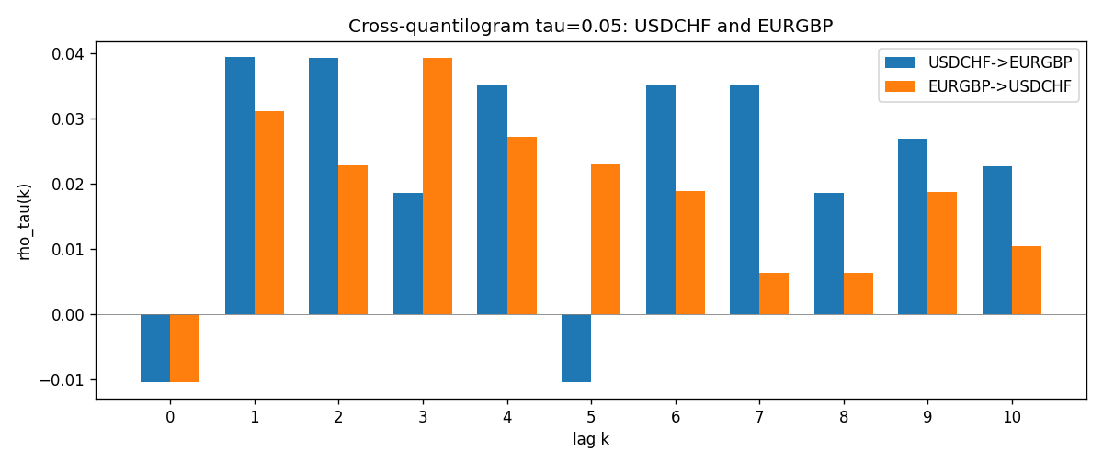

Data report
Matched rows and the CQ sheet are in the sibling Excel workbook named USDCHF-EURGBP_CQ_D1.xlsx. Embedding all rows as a Word table is impractical; this file holds column summaries and the first and last 15 matched rows.
Columns: time, USDCHF_open, EURGBP_open, USDCHF_high, EURGBP_high, USDCHF_low, EURGBP_low, USDCHF_close, EURGBP_close, USDCHF_tick_volume, EURGBP_tick_volume, USDCHF_spread, EURGBP_spread, USDCHF_real_volume, EURGBP_real_volume, USDCHF_log_return, EURGBP_log_return, USDCHF_h_t005, EURGBP_h_t005
Column summaries (matched calculation rows)
column | count | mean | std | min | 25% | 50% | 75% | max
USDCHF_open | 7182 | 1.0972493 | 0.25210985 | 0.72022 | 0.9204925 | 0.989875 | 1.237175 | 1.8219
EURGBP_open | 7182 | 0.7869939 | 0.09664695 | 0.5734 | 0.6877 | 0.833905 | 0.865225 | 0.9769
USDCHF_high | 7182 | 1.1025378 | 0.25385182 | 0.73305 | 0.924695 | 0.99351 | 1.242175 | 1.8313
EURGBP_high | 7182 | 0.79007306 | 0.09702085 | 0.5789 | 0.6897 | 0.836955 | 0.8681 | 0.9799
USDCHF_low | 7182 | 1.092133 | 0.25052689 | 0.08565 | 0.9171825 | 0.986205 | 1.2312 | 1.8121
EURGBP_low | 7182 | 0.7842938 | 0.09646529 | 0.5682 | 0.685725 | 0.83166 | 0.86287 | 0.9661
USDCHF_close | 7182 | 1.09724 | 0.25200902 | 0.72025 | 0.9207375 | 0.98991 | 1.23715 | 1.8217
EURGBP_close | 7182 | 0.78703952 | 0.09664503 | 0.5735 | 0.687825 | 0.83398 | 0.865375 | 0.977
USDCHF_tick_volume | 7182 | 74362.695 | 113509.88 | 18 | 12814.25 | 40258.5 | 70446 | 858589
EURGBP_tick_volume | 7182 | 87145.49 | 145506.26 | 154 | 6593.75 | 44371 | 81432 | 1424684
USDCHF_spread | 7182 | 26.020746 | 24.692144 | 0 | 5 | 16 | 50 | 100
EURGBP_spread | 7182 | 21.320663 | 19.117614 | 0 | 4 | 13 | 40 | 50
USDCHF_real_volume | 7182 | 2.3303821e+10 | 8.915094e+10 | 0 | 0 | 0 | 0 | 1.9331921e+12
EURGBP_real_volume | 7182 | 2.7876168e+10 | 1.3522356e+11 | 0 | 0 | 0 | 0 | 3.5726265e+12
USDCHF_log_return | 7182 | -7.199e-05 | 0.00659004 | -0.19545699 | -0.00335239 | 7.626e-05 | 0.00331734 | 0.09051364
EURGBP_log_return | 7182 | 2.529e-05 | 0.00487429 | -0.03067367 | -0.00262165 | -0.00010006 | 0.00256425 | 0.06075387
USDCHF_h_t005 | 6931 | -0.01667148 | 0.17950594 | -0.05 | -0.05 | -0.05 | -0.05 | 0.95
EURGBP_h_t005 | 6931 | -0.0116217 | 0.19212166 | -0.05 | -0.05 | -0.05 | -0.05 | 0.95
First 15 matched rows (selected columns)
time | USDCHF_log_return | EURGBP_log_return | USDCHF_h_t005 | EURGBP_h_t005
1999-01-06 | 0.013605652 | -0.013303338 | nan | nan
1999-01-07 | -0.0093883841 | 0.011051402 | nan | nan
1999-01-08 | 0.011040268 | -0.004943862 | nan | nan
1999-01-11 | 0.0052963193 | -0.0012752393 | nan | nan
1999-01-12 | -0.0098275602 | 0.0033970309 | nan | nan
1999-01-13 | -0.018259701 | 0.00042381861 | nan | nan
1999-01-14 | -0.0024256692 | -0.0019793588 | nan | nan
1999-01-15 | 0.01794228 | -0.0076715819 | nan | nan
1999-01-18 | -0.0031856384 | 0.00071280921 | nan | nan
1999-01-19 | -7.2518946e-05 | -0.0014261269 | nan | nan
1999-01-20 | 0.0072259871 | 0.0019960086 | nan | nan
1999-01-21 | -0.0038232689 | -0.00071240297 | nan | nan
1999-01-22 | -0.0001445609 | -0.0017118406 | nan | nan
1999-01-25 | 0.0024546976 | -0.0054402425 | nan | nan
1999-01-26 | 0.0020889617 | -0.00057438255 | nan | nan
Last 15 matched rows (selected columns)
time | USDCHF_log_return | EURGBP_log_return | USDCHF_h_t005 | EURGBP_h_t005
2026-10-13 | -0.0024955621 | 0.00020130374 | -0.05 | -0.05
2026-10-14 | 0.0029388325 | 0.0011241873 | -0.05 | -0.05
2026-10-15 | -0.0097855323 | -0.00087557391 | -0.05 | -0.05
2026-10-16 | -0.0036230826 | -0.0020380844 | -0.05 | -0.05
2026-10-19 | 0.0036351779 | -0.00056950988 | -0.05 | -0.05
2026-10-20 | -0.0026281224 | -0.0035906254 | -0.05 | -0.05
2026-10-21 | -0.00040027413 | -0.00140647 | -0.05 | -0.05
2026-10-22 | -0.0048036381 | -0.0018743924 | -0.05 | -0.05
2026-10-23 | 0.005652514 | 0.00082421033 | -0.05 | -0.05
2026-10-26 | 0.0018407959 | 0.00013133309 | -0.05 | -0.05
2026-10-27 | 0.0026100526 | -0.0019957343 | -0.05 | -0.05
2026-10-28 | -0.0010142111 | 0.00066967224 | -0.05 | -0.05
2026-10-29 | -0.0048680164 | -0.0011722209 | -0.05 | -0.05
2026-10-30 | 0.00071594559 | -0.0024205543 | -0.05 | -0.05
2026-11-02 | -0.0071459744 | 0.00089940465 | -0.05 | -0.05

